GANSBAAI GOLF CLUB / GANSBAAI GHOLFKLUB
Weekly Results: / Weeklikse Uitslae:
16 – 22 Sep 2019

Wed/Wo 18 Sep: Sloegters, Single/Enkel Stableford

Winner: / Wenner: George Hunt 36 pts./pte. (photo/foto)
Second: / Tweede: Leon Hattingh 36
Third: / Derde: Clive Bailey 35
Other: / Ander: Solly Wessels 34; Joe Cesare 32; Johan Coetzee 31; Daan Victor 31; Richard Bentz 30; Pierre Lombaard 30; Etienne Engelbrecht 29.

Nearest to the pin: / Naaste aan die pen: Solly Wessels (2); Richard Bentz (8)

Two club’s: / Spog Twee’s: None / Geen

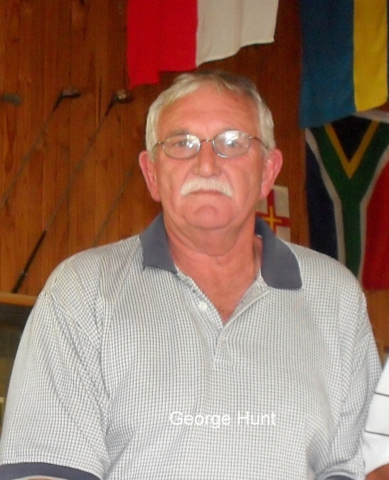

Thu/Do 19 Sep: SAGES, Overberg vs Langeberg, 4BBB Stableford

Overberg (38 ave./gem.) won / wen Langeberg (36,8 ave./gem.)

Winners: / Wenners: Charlie Bent & Trevor Archer 44 pts./pte.
Second: / Tweede: Gert Albertyn & Pieter le Riche 42
Third: / Derde: Deon Steenkamp & Piet de Bod 42.

Fri/Vr 20 Sep: OK-Foods 9-holes/-putjie, Single/Enkel Stableford

No play due to bad weather / Geen spel nie agv swak weerstoestande.

Sat/Sa 21 Sep: 4BBB Stableford – prizes / pryse

No play due to bad weather / Geen spel nie agv swak weerstoestande.

Sun/So 22 Sep: “Sondagskool”
Competition 1: / Kompetisie 1: 9 Holes/Gate Single/Enkel Stableford
Winner: / Wenner: Leon Hattingh 17
Second: / Tweede: Dicky de Kock 16
Third: / Derde: Deon Momberg 16
Other: / Ander: Hennie Kriel 16

Competition 2: / Kompetisie 2: 2-Ball/-Bal American Scramble/Beurtspel, Golf player combined with a non-player / Gholfspeler gekombineerd met ‘n nie-speler
Winners: / Wenners: Monica Laubscher & Stephan 35 pts./pte.
Second: / Tweede: Sakkie van der Merwe & John Smith 36
Third: / Derde: Bertie Laubscher & Ian 38.

Upcoming on your calendar: / Komende vir u dagboek:

Fri/Vr 27 Sep: Monthly Steak-and-Chips event / Maandelikse Biefstuk-en-skyfies aand.
Sat/Sa 28 Sep: Competition 4BBB Medal / Kompetisie 4BBB Houespel.

Let’s play a full field! / Kom ons speel ‘n volBESPREEKTE BAAN!

PLEASE NOTE!
MEMBERSHIP/SUBSCRIPTION FEES:
PLEASE DIRECT ALL QUERIES REGARDING MEMBERSHIP OR FEES
TO JOHAN COETZEE, TREASURER gbgholf@gmail.com
Tel. 028-3841441
THANK YOU!

--oo0oo--

