
premium range
R70
SIngle Vineyard Wines: PER
sugarbush Sauvignon BLanc 2016 R160
Pincushion Sauvignon Blanc 2016 R160
Cat’s Tail Syrah 2015 R300
Conebush Syrah 2015 R300
Limited Releases
Snowbush 2013 R140
Phontom Pinot Noir 2016 R170
BelLadonna SMV 2016 R180

CLASSIC range
R50
ESTATE WINES : PER
Sauvignon BLanc 2018 R85
SSV 2016 R85
SAUVIGNON /
SEMILLON BLEND 2017 R85
MERLOT ROSE’ 2018 R90
SYRAH 2015 R125
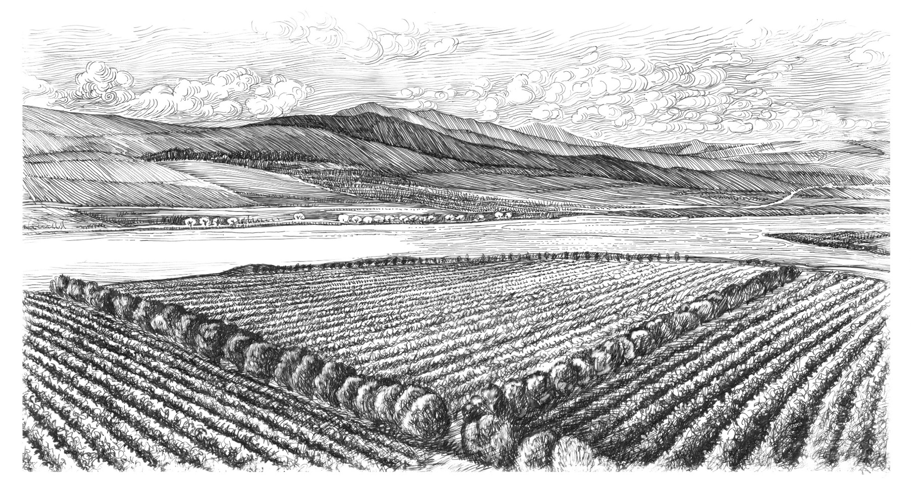
MERLOT 2017 R115

LIMITED RELEASES NOT FOR TASTING

Candelabra Cabernet 2016 by Neels Verburg of Luddite R350
Candelabra Cabernet MAGNUM 2016 by Neels Verburg of Luddite R650
Noble Late Harvest 2017 – Veritas Gold winner 2018 R200

Lomond Estate Sauvignon Blanc |  | 2018 | Released 1 October 2018
Lomond Estate Merlot |  | 2016 | 3 &1/2 Star Platters
Lomond Estate Syrah |  | 2015 | SAWI Gold, 4 Star Platters
Lomond Merlot Rose' |  | 2018 | Double Gold Rose' Rocks
 |  |  | Gold Michelangelo
Lomond Sauvignon Semillon |  | 2017 | Released 14 December 2018
Lomond SSV White Blend |  | 2016 | SAWI Gold, 4 Star Platters
Limited Releases:
Belladonna Shiraz Mouvedre Viognier |  | 2016 | Double Gold Michelangelo, 4 1/2 star Platters
Phantom Pinot Noir |  | 2016 | Was released 1 September 2018
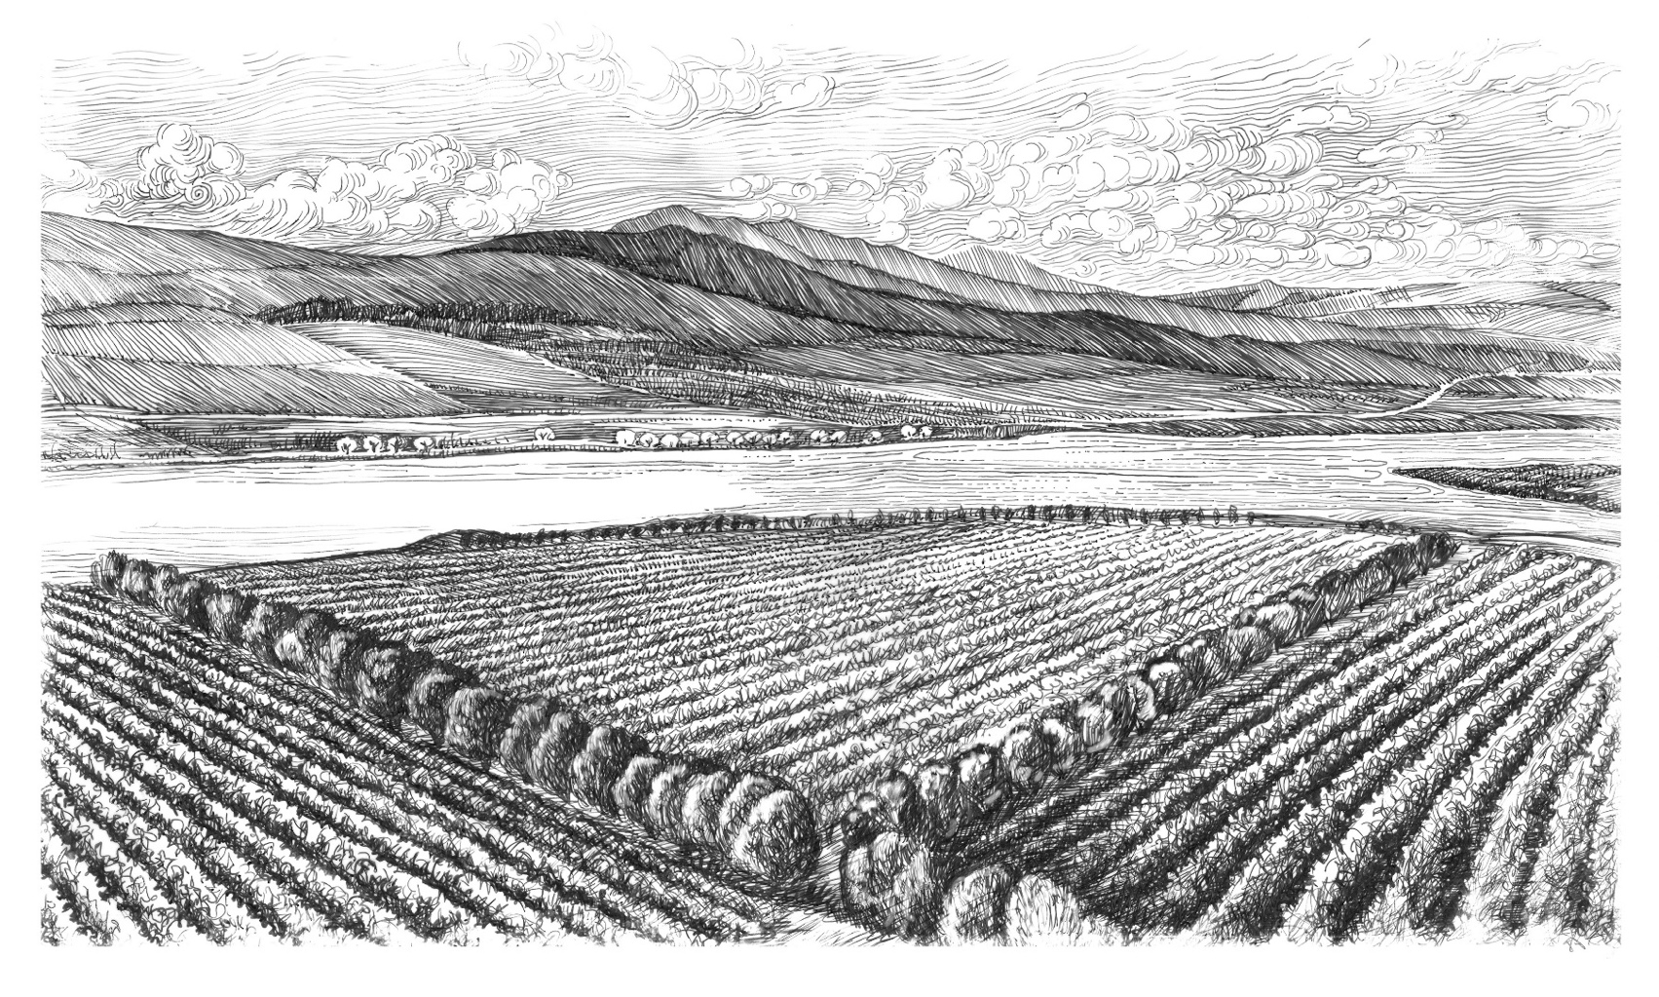  Snowbush White Blend |  | 2013 | The 2012 vintage was on Nederburg Auction in 2018, Tim Atkins 91 Points
Candelabra Cabernet Sauvignon 2016 750ml (500 bottles) & Magnums (120 Bottles) by Neels Verburg of Luddite  Noble Late harvest |  | 2017 | Gold Veritas
Single Vineyards
Sugarbush Sauvignon Blanc |  | 2016 | Veritas Gold, SAWI Platinum,
Sugarbush Sauvignon Blanc |  | 2017 | Tim Atkins 91 Points, SAWI Platinum, 4 stars Platter
Pincushion Sauvignon Blanc |  | 2016 | SAWI Double Gold, 4 Star Platters
Pincushion Sauvignon Blanc |  | 2017 | SAWI Double Gold, 4 Stars Platters
Conebush Syrah |  | 2015 | 4 1/2 stars Platters
 |  |  | Finalist in the Shiraz SA competition, SAWI Platinum
Cats Tail Syrah |  | 2015 | 4 1/2 stars Platters
 |  |  | Tim Atkins 92 Points, SAWI Platinum

