MINUTES OF A ZOOM MEETING OF THE MANAGEMENT COMMITTEE OF THE PEARLY BEACH RATEPAYERS’ ASSOCIATION HELD AT 10H00, ON TUESDAY, 17 NOVEMBER, 2020.
The Chairperson welcomed everyone to the meeting and opened in prayer.

PRESENT : Alderman Dudley Coetzee, (ex officio);
Mr Jason Stonehewer,

Mesdames Shirley Coetzee; Wilma Brent;
Nelia Hurter; Vivienne Burton-Moore

APOLOGIES : Mr Trevor Archer

APPROVAL OF THE PREVIOUS MINUTES

The October 2020 minutes were approved.
Proposed by Nelia and seconded by Vivienne.
MATTERS ARISING FROM THE PREVIOUS MINUTES
INFRASTRUCTURE AND MAINTENANCE
The PB Conservancy has requested holding a “car boot sale” on the village green during December. The PBRPA committee has approved this but concern has been expressed about possible damage to the sprinkler system. The Conservancy will need to take full responsibility for any damage to the sprinkler system. It was suggested that they obtain cones and cover the sprinklers to avoid anyone driving over them. Shirley will ascertain the location of the key for the chain padlock and Viv will send an email to the Conservancy regarding the above issues.
The municipality has placed an order for the materials needed to replace the boardwalk at Rotunda Beach.
The boardwalk at Noorkapper Close has been repaired, although Wilma pointed out that the new planks are thicker than the originals. Alderman Coetzee responded that this is deliberate as the entire boardwalk will eventually be repaired using these thicker planks in the hope that they last longer.
Castle Beach boardwalk has also been repaired, but has since been vandalized again within the last few days. There are also three railings that are loose and there are nails protruding from the slats on the boardwalk. The steps down to the beach have been extended and the boardwalk has been painted.
A suggestion was made that a sign be erected at Castle Beach showing the spots where fishing and swimming are allowed. A sign showing emergency contact numbers should also be placed on the wall of the ablution facilities at Castle Beach. We are still awaiting the “use at own risk” signage for the various boardwalks. It was further noted that some of the signage identifying the various beaches is incorrect and Alderman Coetzee would follow up in this regard.
Some of the pathways down to the beach are overgrown causing people to walk around them creating a wider path.
It was suggested that the name Pearly Beach be added to various conservation boards around the village as many visitors take photographs at these look-out sights. Alderman Coetzee would refer this to the Area Manager.
The ongoing problem with refuse being placed on pavements and in receptacles on days, other than the day that refuse is collected, continues. Anyone witnessing this should take a photograph and forward to Shirley who will report this to the municipality.
The planned controlled burn of large properties that are fire hazards will only take place next year after the fire season. A 20 m fire break will be cleared before any burning takes place.
The Municipal Nature Conservation Department has undertaken to remove any tortoises, animals and chameleons beforehand.
A notice will appear in the November municipal letter stating that estate agents boards will be removed as the by-law states only 2 boards are allowed per property.
FINANCE AND MEMBERSHIP
In the absence of the Treasurer, Shirley reported that R660 has been received so far for membership subscriptions.
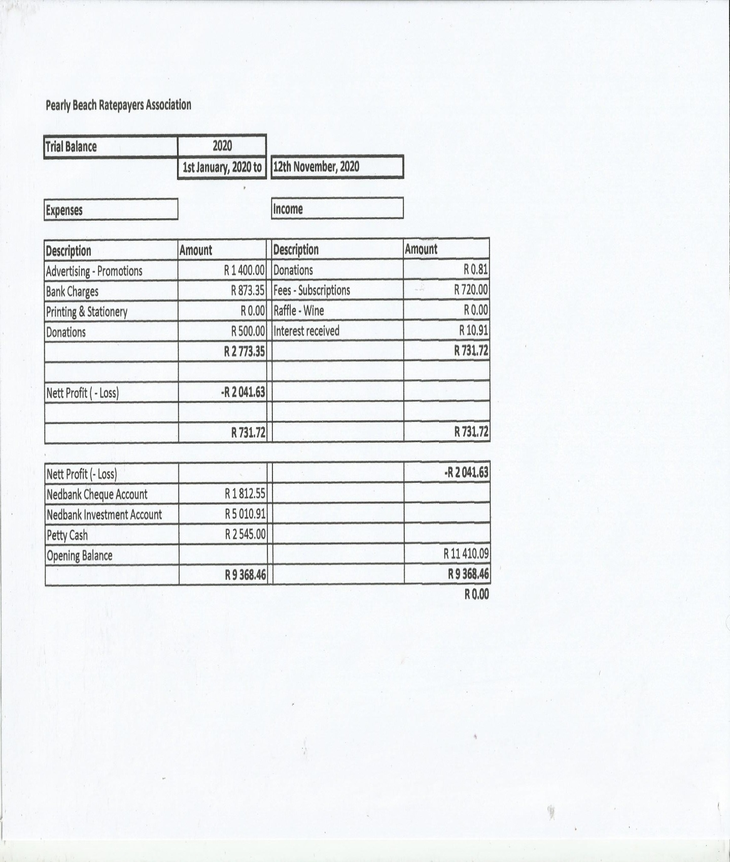

The following Applications for Membership were approved:
Mrs Marion Boltman – Proposed by Vivienne, seconded by Ald. Coetzee
Mr Nils Dreyer – Proposed by Jason, seconded by Ron Huart

BUILDING PLANS AND DEVELOPMENTS
OCTOBER 2020
Village

Erf 22 62 Rotunda Way New House
Erf 1777 10 Jurgens Street Addition
Erf 205 32 Broadway New House

REPORT BACK FROM WARD COUNCILLOR
Fireworks have been banned for the festive season throughout the Overstrand. If anyone observes shop outlets selling fireworks they should be reported to the municipality who will arrange for the confiscation of the fireworks.

Alderman Coetzee stated that the municipality is investigating having a Sound and Light Laser show for New Year’s Eve 2021 (31 December 2021.) Details and venues to be confirmed.

The contract for the continued dust control tarring of streets in Pearly Beach has been awarded and this will commence in January 2021. All roads in Pearly Beach will hopefully be completed by the end of 2021.

A public meeting will be held at the Pearly Beach Angling Club at 4 pm on Thursday, 19 November, 2020, to deal with certain concerns raised by residents and for the community to have an opportunity to address questions pertaining to Pearly Beach to the Ward Councillor.

GENERAL
Vivienne will compile an email address database to pass on information received at the monthly ward committee meetings.
The AGM will take place on the 4 January 2021 at the Angling Club. All sanitization protocols will be in place and will be adhered to. Members will be advised via email as well as on the website.
With nothing further to discuss, the meeting was closed at 10h50.

_____________________ ____________________ ______________
CHAIRPERSON SECRETARY DATE

