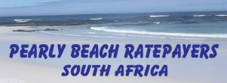
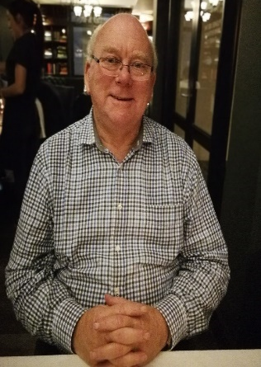
SO LONG, FAREWELL ....
On 1 November, 2021, Alderman Dudley Coetzee, Ward Councillor for Ward 11, since 2011 bid farewell to his ward to take up the position of ward councillor, in the newly formed Ward 1 (which comprises mainly Stanford.) We extend our thanks to Dudley for his service over the last ten years – and more recently during his tenure as Mayor of the Overstrand. We wish him well as he concentrates his efforts on serving the Stanford community.

WARD COMMITTEES (2022 – 2026)
The election of ward committees for the next 5 years recently took place during November. We are grateful that the PBRPA will once again be represented on the ward committee. Thank you to the residents of Pearly Beach for voting for our local organisations to serve on the ward committee. Other Pearly Beach organisations who have a seat on the ward 11 committee are the PB Conservancy, the Eluxolweni Youth and the Eluxolweni Regional Block. The other members of the Ward Committee are the Franskraal Buurtwag, Franskraal Ratepayers’ Association, B’Bos Home Owners’ Association, Klipfontein Home Owners’ Association, Viljoenshof Regional Block and Buffeljachtsbaai Regional Block.
PEARLY BEACH RATEPAYERS’ ANNUAL GENERAL MEETING
The management committee has decided that due to the postponement of the local government elections, that our AGM be held in March 2022. The date of the AGM will be confirmed at the first meeting of the New Year in January and members will be advised accordingly.
If you haven’t yet paid your subscriptions, please do so without delay so that Trevor Archer, our Treasurer, can end the year on a high note! Membership fees are R40 for single membership or R60 for family membership (i.e. two people occupying the same property. Banking details are as follows: Pearly Beach Ratepayers’ Association, Nedbank, Gansbaai a/c 119 073 4141. Branch code 198 765. NO CASH DEPOSITS PLEASE!
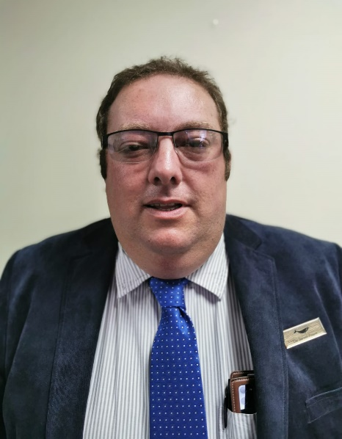
Proof of payment to Trevor at tja@sbsa.com
A WARM WELCOME TO COUNCILLOR STEVEN FOURIE
We are pleased to welcome our newly elected Ward Councillor, Steven Fourie, to Ward 11. Ward 11 comprises Franskraal, Pearly Beach, Baardskeerdersbos, Viljoenshof, Withoogte and Buffeljachtsbaai.
Steven is the 8th generation of his family to reside in Baardskeerdersbos.
He has been involved in civil society since leaving high school when he became active in the Farmers’ Union and the Ratepayers’ Association. In 2001 he joined the DA branch. In 2016, he was elected to the Overberg District Council. He has also served as Chairperson of the Section 32 Fruitless and Wasteful Expenditure Committee, the Municipal Coastal Committee, as well as the Regional Waste Forum, and the Karwyderskraal Monitoring Committee.
Steven is interested in ancient history, in particular, Ancient Egypt. He loves politics and enjoys reading. He is currently reading “Churchill & Smuts, “Die Vriendskap” by Richard Steyn.
He is an avid vegetable gardener and a keen cat person, who says he believes in the mantra “only intelligent people understand cats!”
Strength to you, Steven!

We encourage you to visit our Association on the Xplorio platform at https://xplorio/gansbaai/pearly-beach-ratepayers/ where you can access the minutes of our monthly committee meetings and keep up to date with projects and activities in the village.
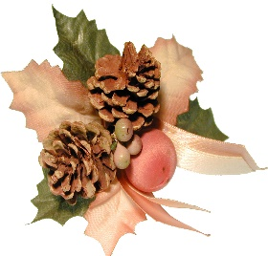
I am sure that you have noticed that Computer Hut is busy installing fibre cables in Pearly Beach. According to their Operations Manager, the system should be installed and active within the next eight months.

Finally, may we take this opportunity of wishing you and your family every blessing this festive season. May joy, good health and prosperity be yours to enjoy in 2022.

Affectionately
Shirley
SHIRLEY COETZEE
CHAIRPERSON
PEARLY BEACH RATEPAYERS’ ASSOCIATION

