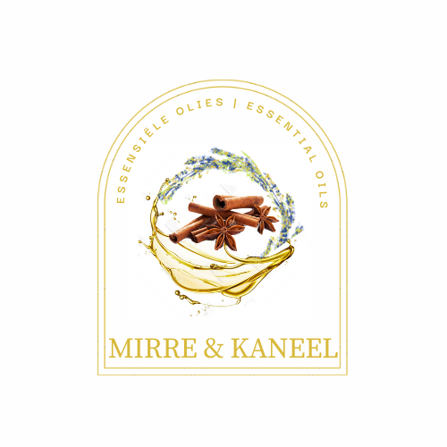
Mirre & Kaneel
Essential Oil Shop
14 Harbour Road
Kleinmond
https://www.mirrekaneel.com/

Price list all products
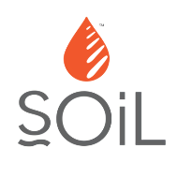

Soil Products
***Do not use during pregnancy
*Do not use if you have high blood pressure

Carrier oils
Apricot Kernel 30 ml R69,00
Apricot Kernel 100ml R139,00
Kalahari Melon Seed Oil, Soil, Organic, 30ml R99,00

Ready-to-use blends
Baby Masssage Oil 100ml, Soil R119,00
Uplifting Massage Oil 100ml, Soil R119,00

Ready-to-use Diffuser blends
Myrrh B&W = Myrrh Beauty and Wellness

Uplifting
Always Rejoice Myrrh B&W R269,00
Inspire Blend, 10ml ,Soil R79,00

Reduces stress and anxiety
Breath of God Myrrh B&W, 5ml
Emotional harmony & serenity R129.00
Balance Me
Hormone Balancing, 10ml R269,00
Sleep Blend, 10ml, Soil R149,00
Focus Blend, 10ml, Soil R59,00
Inspire Blend, 10 ml Soil R79,00

Essential Oils
Bergamot, Soil, Organic R149,00
Black Pepper, Soil, Organic R99,00
Cedar Wood, Soil, Organic R59,00
Chamomile, Roman, Soil, Organic R199,00
Cinnamon Leaf, Soil, Organic R49,00
Clary Sage, Soil, Organic*** R149,00
Clove Bud, Soil, Organic R79,00
Coriander Seed, Soil, Organic R139,00
Cypress, Soil, Organic R89,00
Eucalyptus, Soil, Organic R29,00
Frankincense, Soil, Organic 5 ml R99,00
Ginger, Soil, Organic R129,00
Grapefruit, Soil, Organic R119,00
Jasmine blend for diffuser, Myrrh B&W R169,00
Juniper Berry, Soil, Organic R109,00
Lavender, Soil, Organic R99,00
Lemon Organic Soil R39,00
Lemongrass, Soil, Organic R49,00
Lime, Soil, Organic R79,00
Mandarin, Soil, Organic R69,00
Marjoram, Soil, Organic R159,00
Melissa, Soil, Organic*** R199,00
Myrrh Conv Soil*** R149,00
Niaouli, Soil, Organic R39,00
Palmarosa, Soil, Organic R79,00
Patchouli Organic Soil R99,00
Peppermint, Soil, Organic R69,00
Petitgrain, Soil, Organic R89,00
Pine, Soil, Organic R69,00
Rose blend for diffuser R99,00
Rose Geranium R149,00
Rosemary, Soil, Organic*** R59,00
Sandalwood, Soil, Organic R249,00
Sweet Basil Soil Organic R59,00
Sweet Orange, Soil, Organic R39,00
Tea Tree, Soil, Organic R49,00
Thyme Soil Organic R129,00
Vetiver, Soil, Organic R229,00
Ylang ylang Organic Soil R129,00

Diffusers and Burners
Diffuser, 185ml R399,00
Ceramic burners, Soil R139,00

Soy wax melts
Soy Wax Melts, Lavender R69,00
Soy Wax Melts, Lemongrass R69,00
Soy Wax Melts, Peppermint R69,00
Soy Wax Melts, Rose Geranium R69,00
Soy Wax Melts, Spice Blend R69,00
Soy Wax Melts, Ylang Ylang R69,00

Shea Butters
Shea Butter, Organic Citrus R149,00
Shea butter, Organic, Lavender R149,00

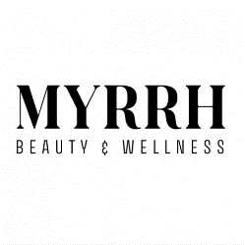

Myrrh Beauty and Wellness products
*AO = Anointing Oil – is blended on olive oil do NOT use in diffuser – it will clogg your diffuser

Anointing Oils
Breath of God AO R95,00 symbolises the strength of God – space He creates for you, peace
Fig AO R95,00 Symbolises new beginning
Frankincense AO R95,00 Prayer and Intercession
Hyssop AO R95,00 The blood of Christ
It is complete AO R95,00 The complete work of the cross
Myrrh AO R95,00 Bitter experiences changing to an unexpected gift
Oil of Joy AO R95,00 The fragrance of the Messiah
Streams in the desert AO R95,00 Provision (financially and in all other areas of life)

Hand creams
Ester Lotion Myrrh 150ml R79,00
Ester Lotion Rose R79,00



Aloe Ferox Products

Aloe Ferox, ( AM facewash ) R80,00
Aloe Ferox, Cleanser, Foaming R72,00
Cleansing Cream R50,00
Aloe Ferox, Moisturizer, 50ml R52,00
AM Moisturiszer 80,00
AM Aloe Gel R110.00
Aloe Ferox, Night Cream, 50 ml R85,00
Aloe Ferox, Enriched Night Cream, 50ml R95,00
Aloe Ferox, Balancing Toner, 200ml R105,00
Aloe Ferox, Wrinkle-Less, 50ml R105,00
Aloe Ferox, Mature, 50ml R115,00
Aloe Ferox, Ultra-Rich Night, 50ml R92,00
Aloe Ferox, Rejuvenating Essence, 50ml R120,00
Aloe Ferox, Whole leaf gel, 75ml R92,00
Aloe Ferox, Muscle gel, 75ml R80,00
Aloe Ferox, Super Aloe gel, 75ml R85,00
Aloe Ferox, Aloe Tissue Oil, 100ml R90,00
Aloe Ferox, X-Balm, 50ml R50,00
Aloe Ferox, Moisturizing Mask, 50ml R58,00
Aloe Ferox, Facial Mask, 50ml R55,00
Aloe Ferox, Refining Scrub, 50ml R70,00
Aloe Ferox, Moisturizing, Day, 50ml R90,00
Aloe Ferox, Eye Gel, 15ml R53,00

Aloe Ferox, Hand Cream, 75ml R52,00
Aloe Ferox Hand cream, Jasmine 200ml R60,00
Aloe Ferox, Nail & Cuticle, 15ml R44,00
Aloe Ferox, Revitalizing Shampoo, 200ml R55,00
Aloe Ferox, Hair & Body Wash, 200ml R58,00
Aloe Ferox, Shower Gel, 250ml R60,00
Aloe Ferox, Nutri Hair Conditioner, 250ml R92,00
Aloe Ferox, HL Shampoo, 100ml R58,00
Aloe Ferox, HL Conditioner, 100ml R58,00
Aloe Ferox Fabulous fibre tablets R105,00
Aloe Ferox Fabulous Fibre Capsules R105,00
Aloe Ferox Multiplus R92, 00
Bitter Aloe Gel R86,00
Spotless R98,00
Sweet Feet R58, 00
Sinase Spray R55, 00

Arborie Skincare (Moringa seed oil based)



The One

Moringa Seed Oil - 100ml R249,00
Moringa Seed Oil, 30ml R149,00
Moringa Seed Oil, 10ml R79,00

Nourished
Anti-ageing Facial Oil, 30ml R249,00
Anti-ageing Facial Oil, 10ml R139,00

Fresh
Day Treatment Cream, 50ml R149,00

Plump
Hyaluronic Acid Serum, 30ml R299,00

Body Velvet
Neroli, 200ml R149,00
Jasmin, 200ml R149,00

Clear
Face Wash, 200ml R159,00

Pure
Oil Cleanser, 100ml R149,00

Men
Beard Oil, 30ml R139,00
Aftershave, 30ml R139,00

Lip balm
Lip balm, 12g R32,00

